TRIBHUVAN UNIVERSITY
PATAN MULTIPLE CAMPUS
PATANDHOKA, LALITPUR

LAB REPORT
SOFTWARE ENGINEERING (BIT 302)

SUBMITTED BY: | SUBMITTED TO:
NAME: SURESH DAHAL | DEO NARAYAN YADAV
CLASS: BIT – III/I
ROLL: 23 | ________________________
DATE: 2082-12-01 | CHECKED BY

LAB-2: WHAT IS SYSTEM MODELING? EXPLAIN DIFFERENT PERSPECTIVES OF SYSTEM MODELING. USE DRAW.IO OR ANY OTHER CASE TOOLS TO DRAW THE USE CASE DIAGRAM, ACTIVITY DIAGRAM, SEQUENCE DIAGRAM, CLASS DIAGRAM AND COMMUNICATION DIAGRAM.
THEORY:
System Modeling is the process of creating pictorial representations of a system to better understand, design, and communicate its structure and behavior. System models are usually created using Unified Modeling Language (UML) diagrams and tools like draw.io.
PERSPECTIVES OF SYSTEM MODELLING:
There are four main perspectives of system modeling. They are given by:
- External Perspective:
This perspective shows how users interact with the system without describing internal processes. Context diagram is an example of an external perspective.

- Interaction Perspective:
This perspective focuses on how components or objects communicate with each other during system operation. Sequence diagrams and communication diagrams are some examples of interaction perspective.

- Structual Perspective:
This perspective describes the static structure of the system, including classes, attributes, and relationships. It acts as a blueprint of the system. It shows what the system is rather than what it does. Class diagram is an example of structural perspective.

- Behavioral Perspective:
The behavioral perspective focuses on how the system behaves over time and how different activities or processes are carried out. It shows the flow of actions, decisions, and operations within the system and how the system responds to different events or inputs. Activity diagram is an example.

FUTSAL BOOKING AND MANAGEMENT SYSTEM
- USE-CASE DIAGRAM:
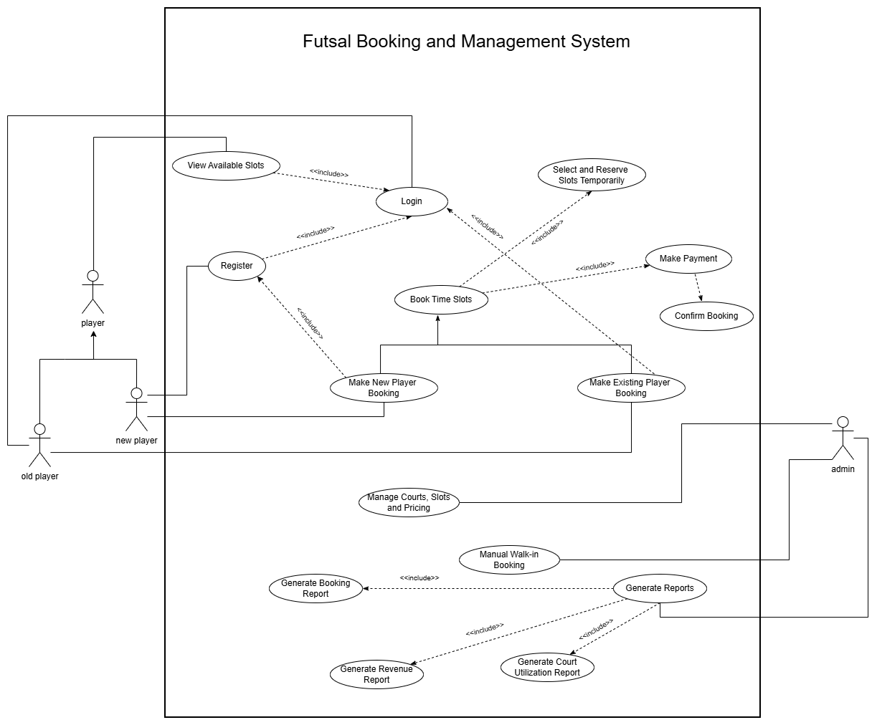

- ACTIVITY DIAGRAM
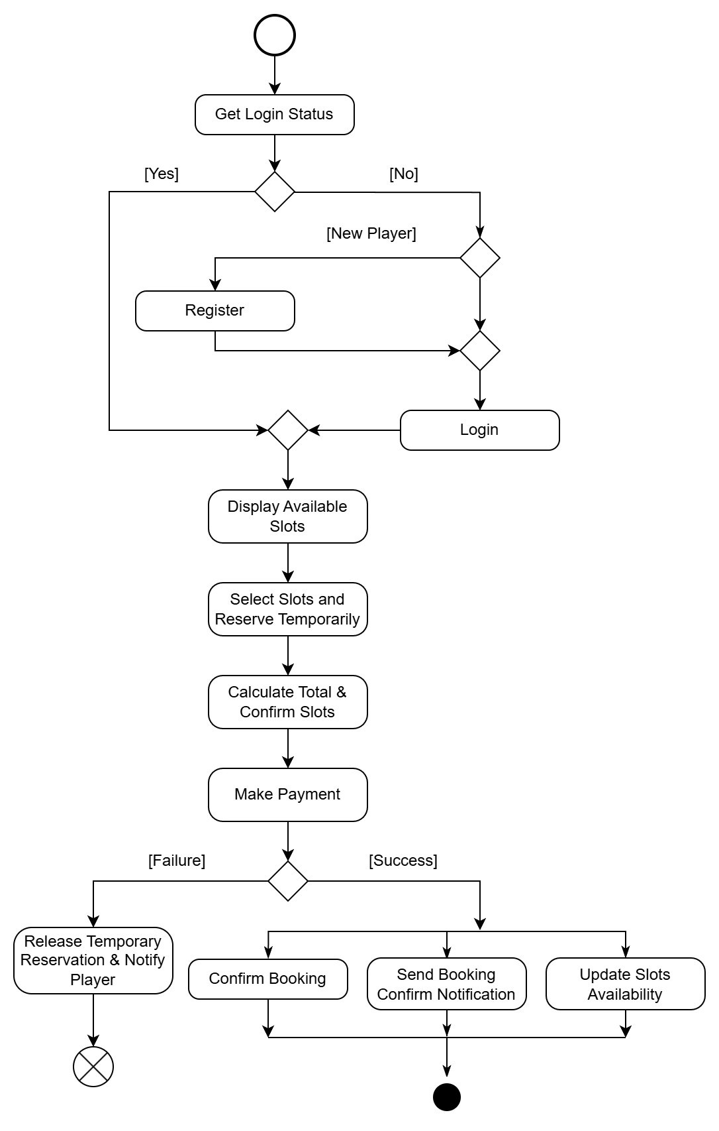

- CLASS DIAGRAM
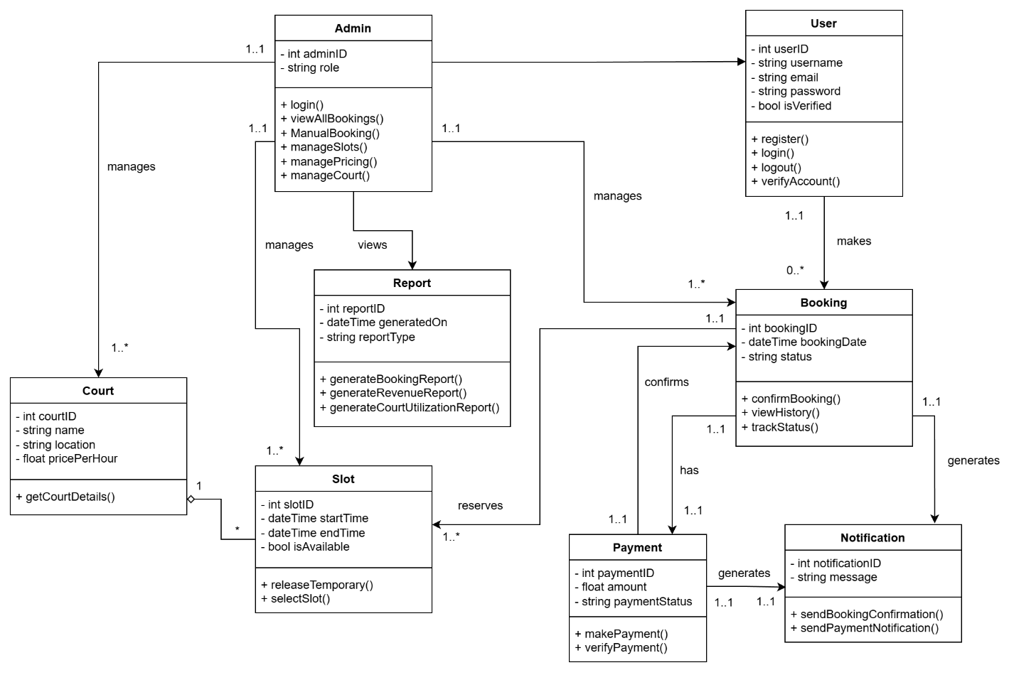

- SEQUENCE DIAGRAM

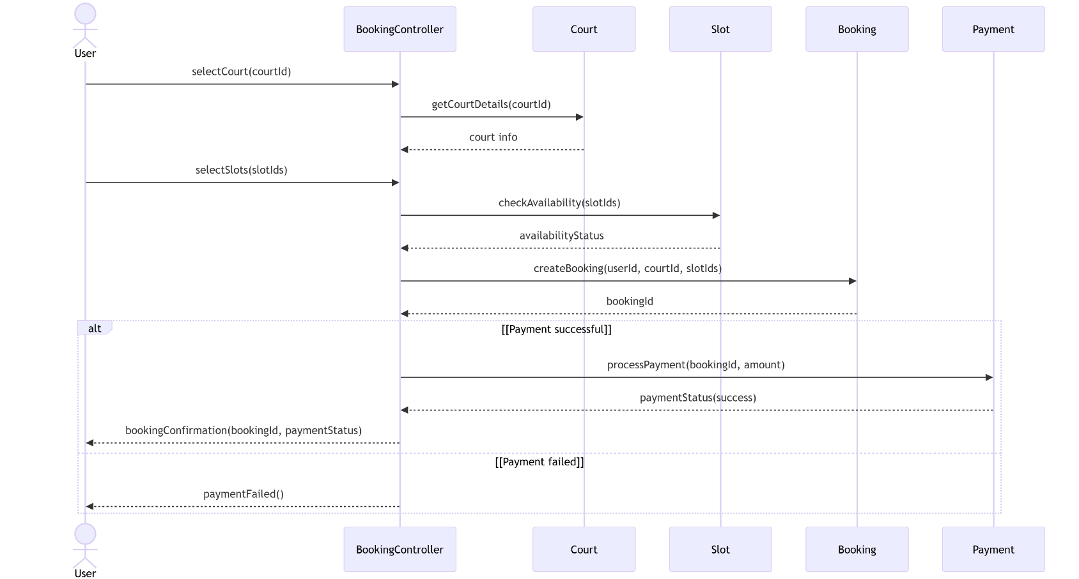

- COMMUNICATION DIAGRAM
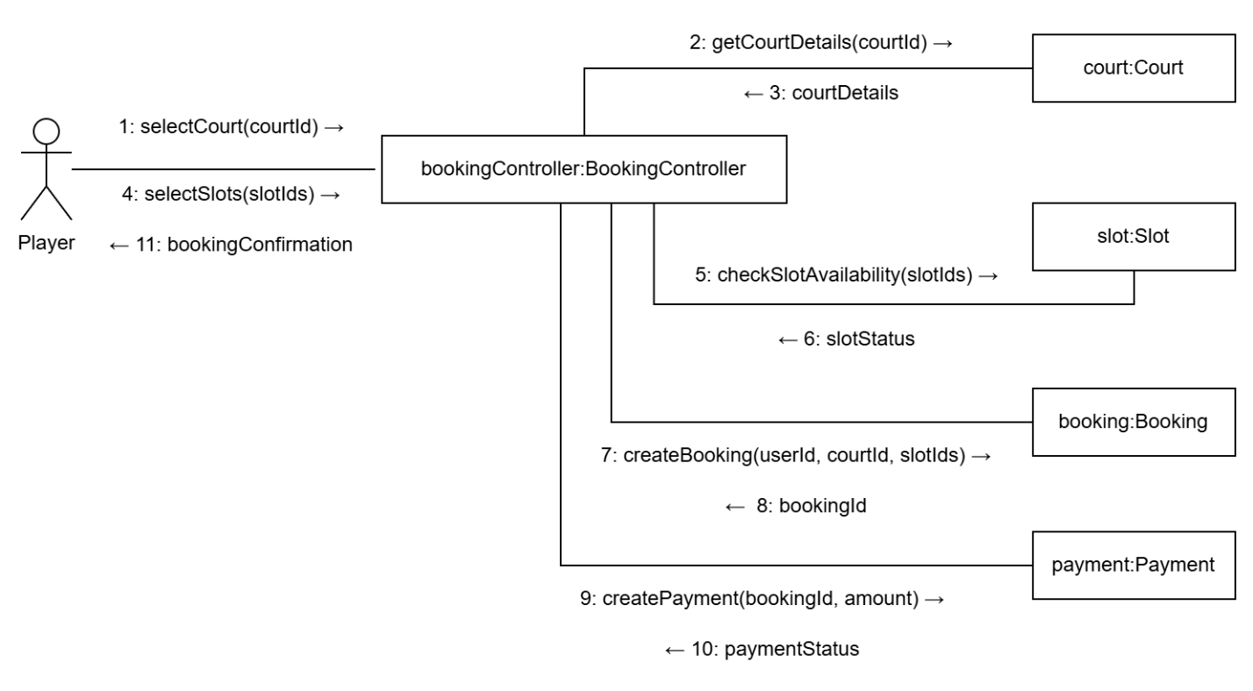

CONCLUSION:
Hence, through this lab, we learned that system modeling is essential for visualizing a project before actual implementation. By looking at a system from external, structural, behavioral, and interaction perspectives, we can understand both its static design and its dynamic logic.

